Andres Trujillo

CS 255 System Analysis and Design

Prof. McHann

4/21/2024

# CS 255 System Design Document

## UML Diagrams

### UML Use Case Diagram

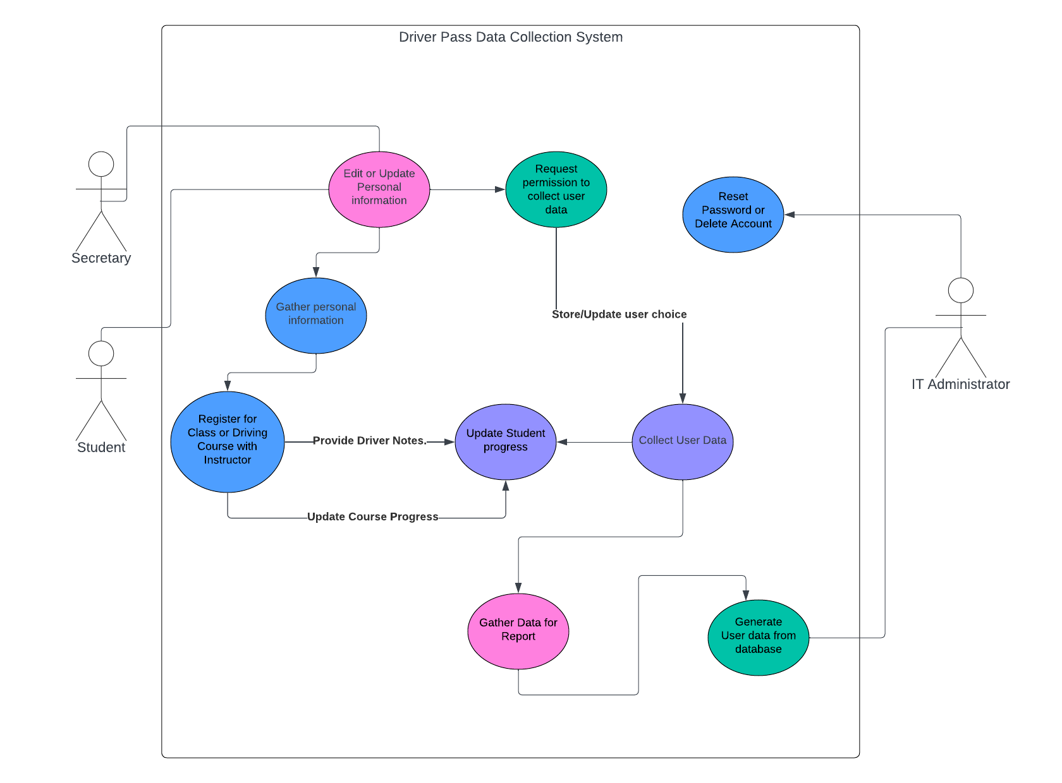

UML Activity Diagram

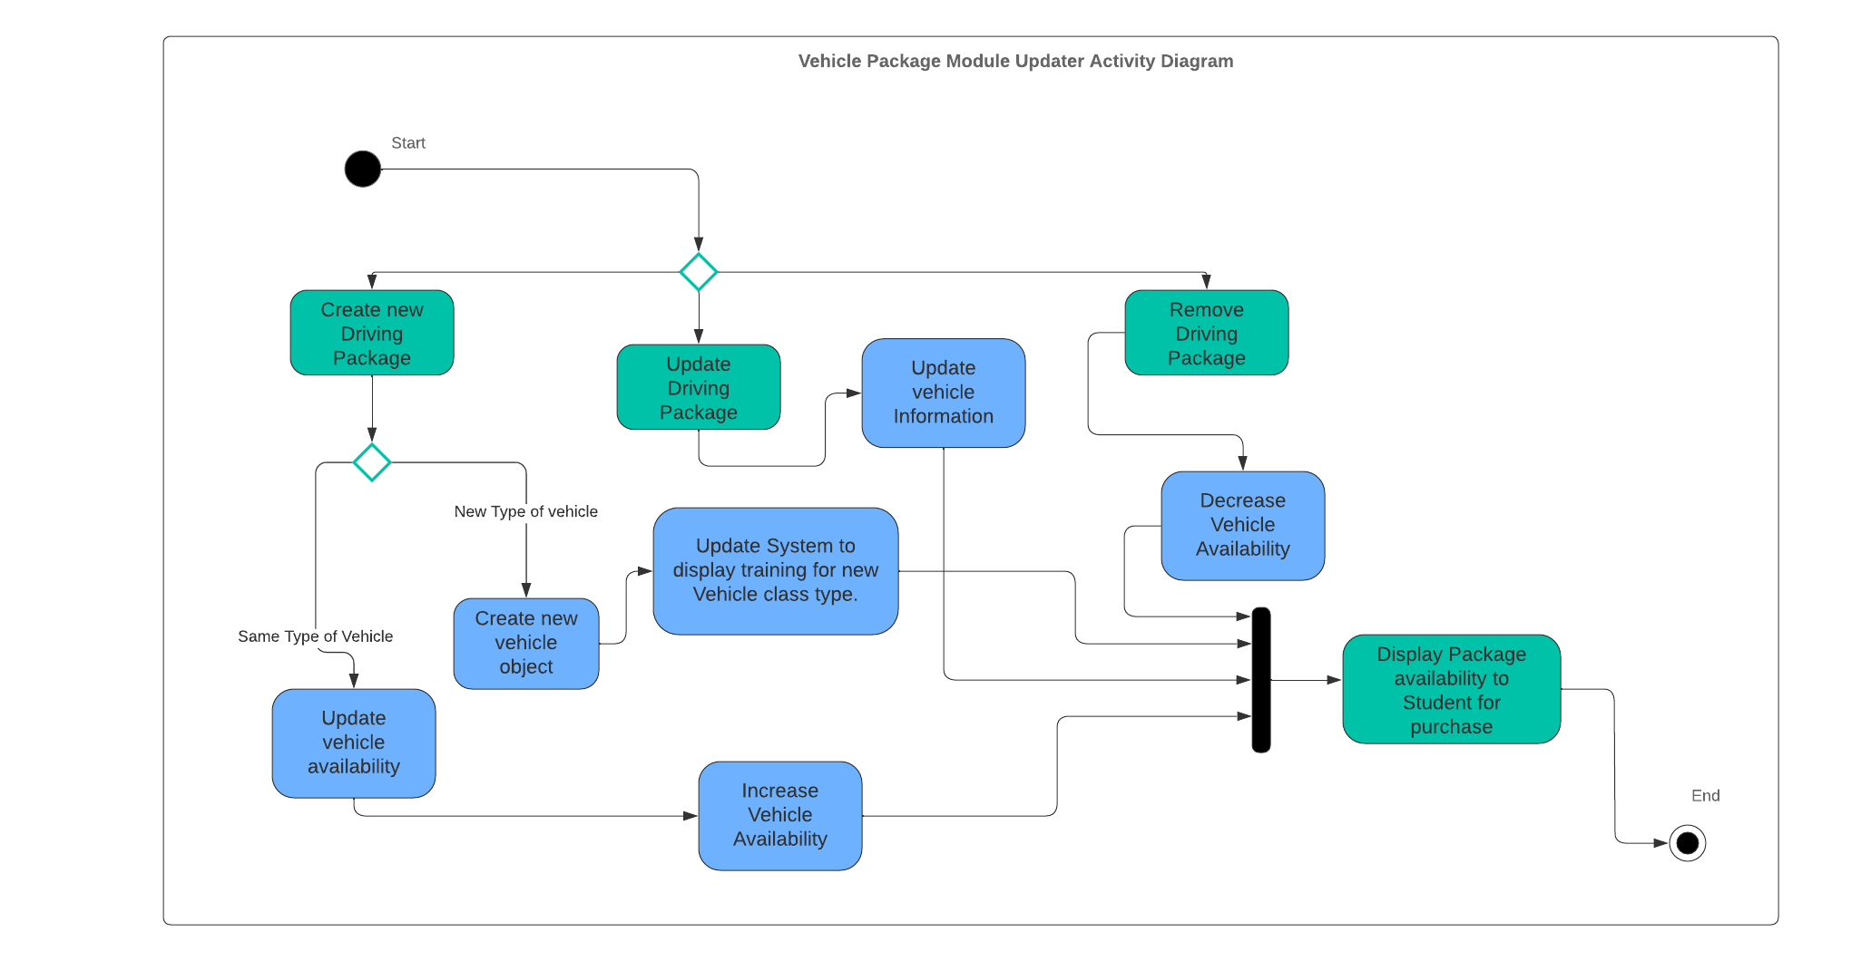

### 

### UML Sequence Diagram

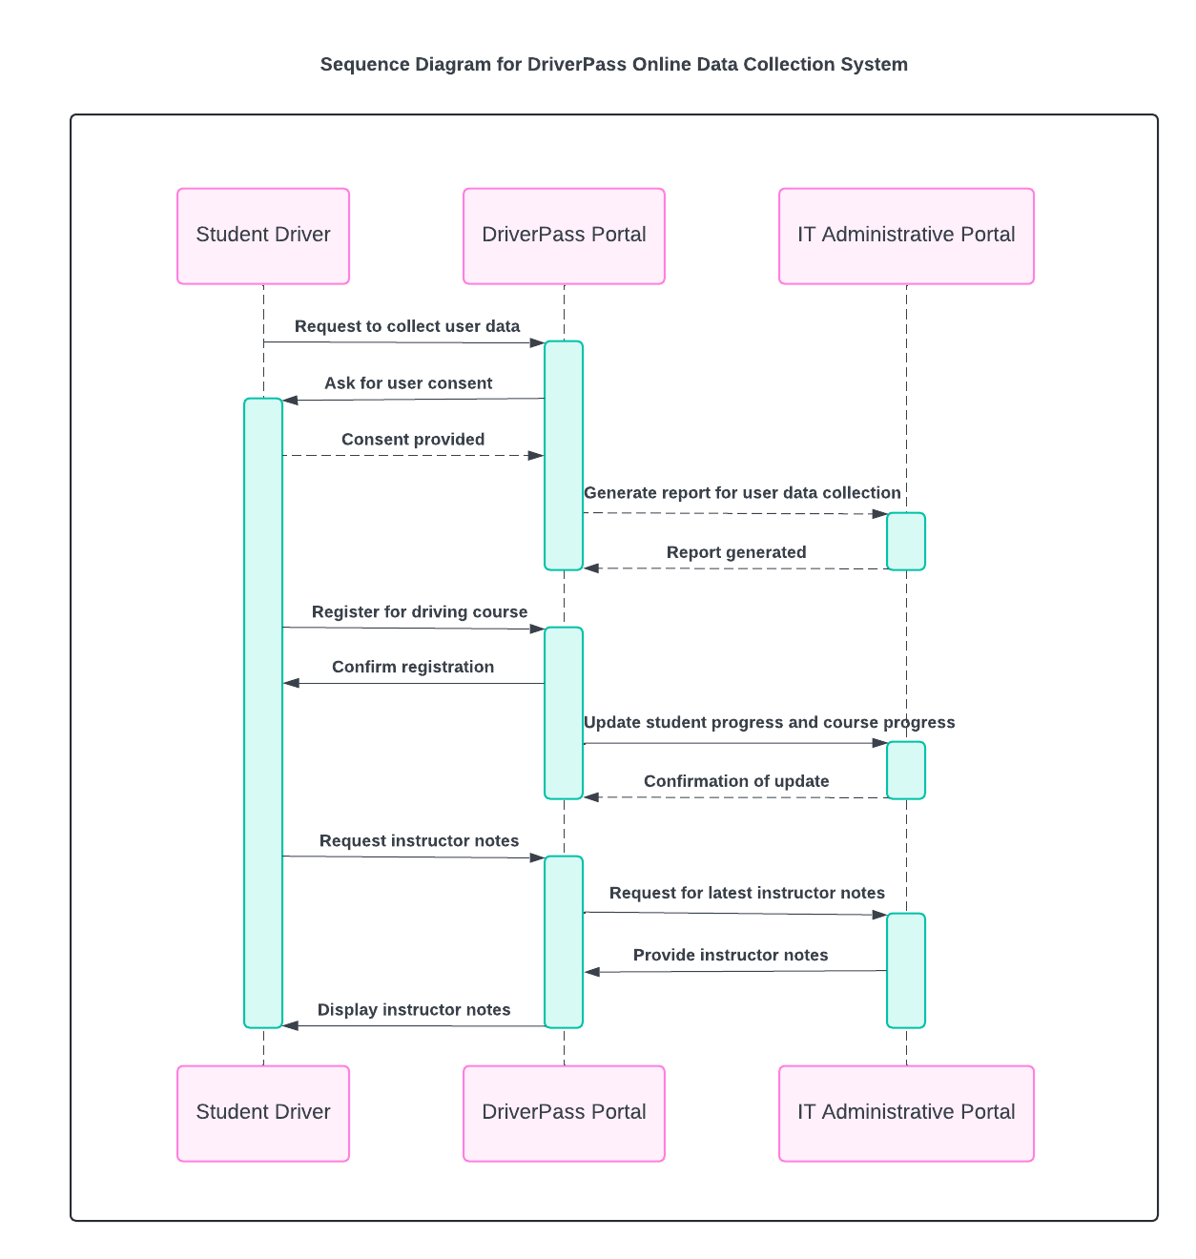

### UML Class Diagram

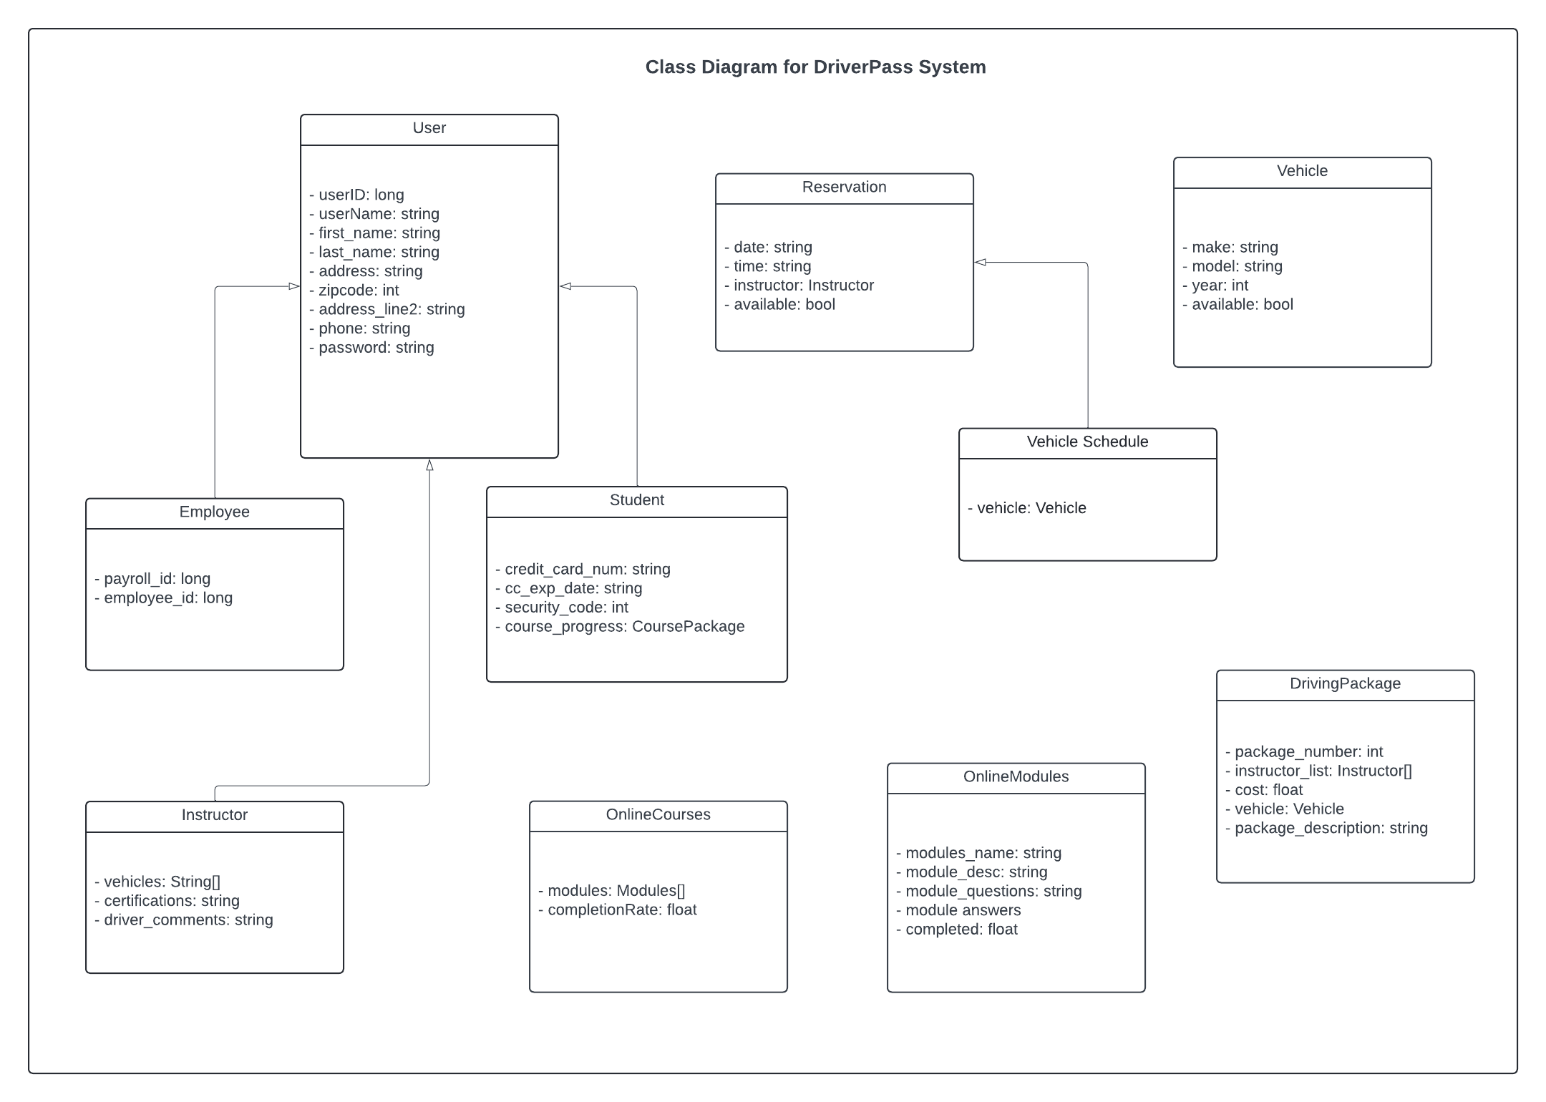

## Technical Requirements

* Website will run off Amazon servers, so we have access to database, simple storage and a guaranteed uptime of 99.99%.
* The website will be written in HTML, CSS, and use JavaScript or TypeScript to provide a user interface.
* There will be a registration portal for students and an account already made for an administrative person such as IT to monitor network/storage space and bandwidth to project future or current costs.
* The server side will validate SQL queries after the user browser validates input to ensure sanitized hits to the database mitigating dangerous vulnerabilities to user data.
* The front-end will communicate with the backend using HTTPS/TLS 1.2 with appropriate certificates to ensure encrypted web traffic.
* The amount of storage needed will be about 10mb for personal information from the student and one or two credit cards. This traffic can be compressed even further in my opinion before being stored.
* Most storage needed will be for driving packages and the driver training schedule but that will still be exceptionally low.
* The driving packages could potentially be costly if ever upgraded to video streaming instruction, but PDF’s and other text-based course material has a minimal impact to the financial cost before a million concurrent users.

**References**

Valacich, J., Valacich, J. S., & George, J. (2019). *Modern systems analysis and design*. Pearson.